DAY 14 – 29.04.2024 OUTPUT SCREENSHOTS – LEETCODE PROBLEMS IN VISUAL STUDIO (C#)

MINIMUM DEPTH OF BINARY TREE:

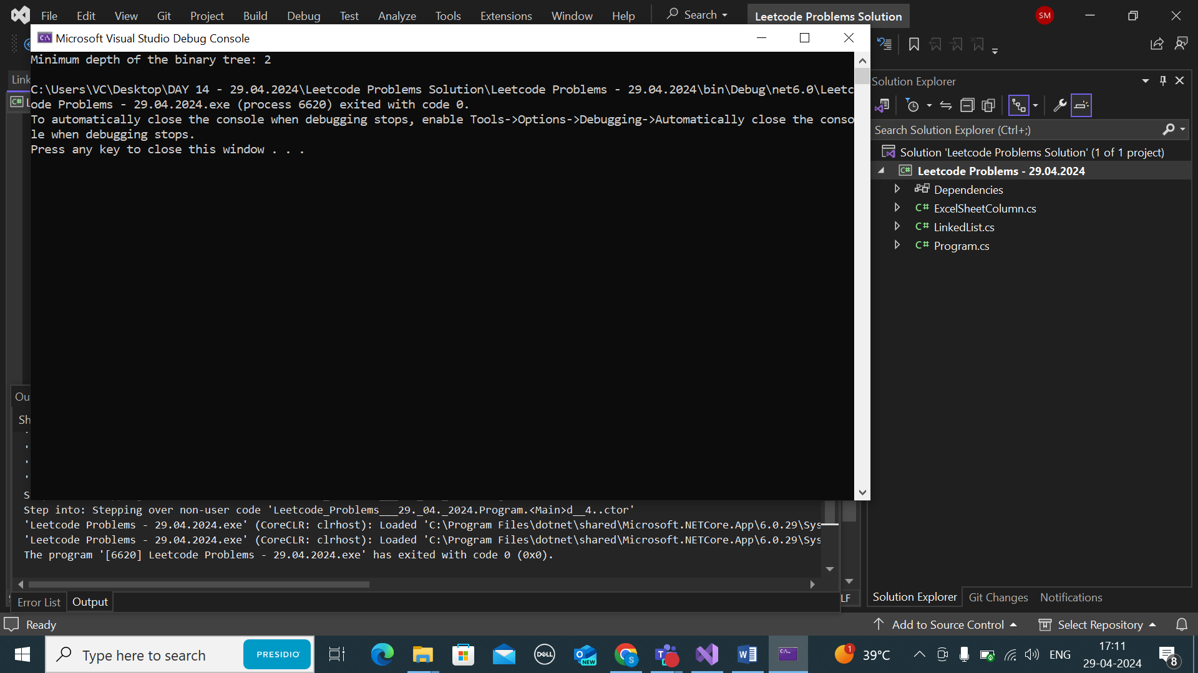

EXCEL COLUMN NUMBER:

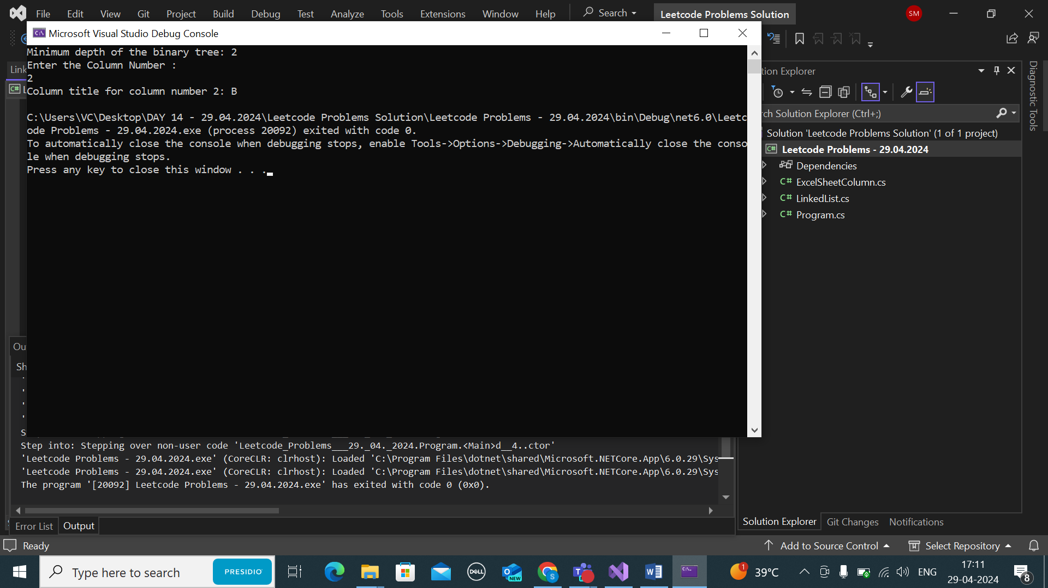

LINKED LIST CYCLE

